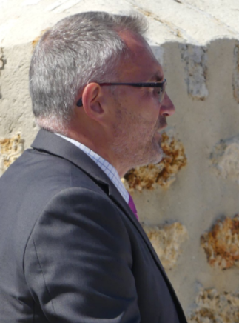 | Discours Dominique Moyse  Conseil régional, représentant du Président du Conseil régional Hauts-de-France  Mémorial de la Ferme de la Croix Rouge – 28 juillet 2018
Monsieur le Préfet, Monsieur le Député, Monsieur le Sénateur, Monsieur le Président du Conseil départemental, Madame Monsieur les Conseillers départementaux, Monsieur le Maire de Fére en Tardenois, Mesdames, Messieurs les élus, , Mesdames Messieurs les représentants des anciens combattants, Mesdames Messieurs les portes drapeaux, Mesdames Messieurs les officiers et sous officiers, Messieurs les militaires venus ici sur la trace de vos aïeux, Mesdames, Messieurs,
I would like to begin by saluting the tremendous work carried out by those who have made this day possible since this morning in Seringes-et-Nesles, passing by this midday in Fère-en-Tardenois, then here, and this evening at the Fantômes de Landowski. We are gathered here to commemorate the American soldiers of the 42nd Infantry Division "Rainbow" consisting of the 167th Alabama Regiment and 168th Iowa Regiment who fell here by the thousands. We are gathered before a monument of great strength and powerful emotion.
I will not go back over what happened here 100 years ago, it has already been done and others probably do it also. As representative this afternoon of the President of the Regional Council, Xavier BERTRAND, and elected representative of this territory which suffered so much during the First World War and which bears many stigmata, I would like to say how important I feel it is to remember and pass on the stories of these men, whatever their nationality, who died so that we can enjoy freedom. I also want to have a thought for the women, mothers or wives of these men who also played their part in this painful episode of our history.
The commemoration of the centennial of the end of the First World War has brought up many names and faces of soldiers who died for France in our local news. Many initiatives have been taken, by associations, municipalities, veterans. They have given or will give the opportunity to pay tribute to men who have fallen on our soil and whose memory must be perpetuated; they are also important moments for our national community. These various initiatives and the popular enthusiasm that they arouse are proof that our fellow citizens are still responsive today to a collective commitment to memory and remembrance.
These times of commemoration are essential, because building our future without remembering our past would run the risk of repeating the same mistakes. The horror has been described in poignant testimonials allowing each of us to become aware of the atrocities committed during the various conflicts.
Today, how can we ensure that the tenuous thread that connects us to this past does not disappear? Our collective duty to preserve and transmit testimonies is even greater. We work on it in the Regional Council, in connection with the territories, as well as on tourism of memory. It is an occasion to bring to the knowledge of the greatest number this collective history by our desire to make our common history also available for those who visit our region.
However, memory is not history. Where history describes facts, memory reveals emotion and suffering. How to be moved when the owners of the emotional charge have disappeared? How to keep memory alive? These are the challenges before us. It is an important work which undoubtedly begins with learning, with the acquisition of knowledge, in a word through the school, by fulfilling our obligations as memory passers.
It is essential that our actions of memory are not only turned towards history but also in tune with our present which will determine what will be our common future and the one of future generations!
Thank you very much

