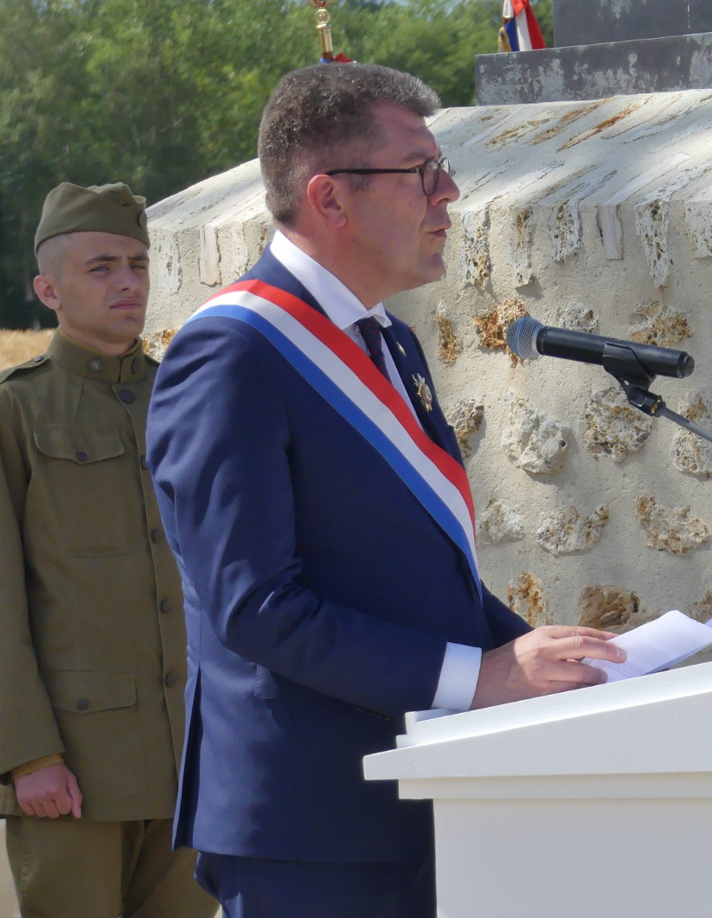 | Discours Antoine Lefevre  Sénateur de l’  Mémorial de la Ferme de la Croix Rouge – 28 juillet 2018

I have a rendezvous with Death  At some disputed barricade,  When spring comes back with rustling shade  And apple-blossoms fill the air -  I have a rendezvous with Death  When spring brings back blue days and fair. (...) | (J'ai un rendez-vous avec la Mort  Sur quelque barricade âprement disputée,  Quand le printemps revient avec son ombre frémissante  Et quand l'air est rempli des fleurs du pommier  J'ai un rendez-vous avec la Mort  Quand le printemps ramène les beaux jours bleus)

Monsieur le Préfet, General Presiding the Rainbow Division Veterans Foundation, General Commanding the 42nd Division, Défense Attaché of the German Embassy, Monsieur le Député, Monsieur le Président du Conseil Départemental, Monsieur le Conseiller Régional, Mme the President of the Croix Rouge Farm Memorial Foundation, dear Monique Seefried, Messieurs les Maires, Mesdames, Messieurs,

These verses come from the famous poem "I have un rendez-vous with death" by the American poet Alan Seeger. On July 4, 1916, on the day of American Day, Seeger who was fighting for France in the Foreign Legion died in action at Belloy-en-Santerre. This poem, one of President John Fitzgerald Kennedy's favorites, evokes in a remarkable way through opposition figures, war and peace, life and death. While Seeger expands on life and peace through images of spring, for war the only word is death. But probably also because the poet lacks words to describe the horror of war.
This year 2018 marks the centennial of the end of the First World War. A devastating conflict for human history. A conflict whose proportions had never been known before this early twentieth century. Nations against nations, nations dragging nations into the whirlwind of hatred and destruction. The murderous madness unleashed on a planetary scale. The planet organized for and by war. The toll: 10 million dead, 8 million disabled, more than 12 million refugees forced to flee military actions. France was proportionally the most affected country in terms of human losses; 1.5 million dead, 1.4 million disabled.

Today, a hundred years after this terrible episode in our history, several ceremonies are being held in France and around the world to commemorate the various battles, to pay tribute to the soldiers who died in combat but also to celebrate the end of the conflict. Rites are organized around memory. But what memory? Memory is a product of the present, a social construct that over time can acquire different meanings, each generation interpreting the same event according to its own moment.

I wonder therefore about the meaning of these commemorations around the First World War taking place in 2018? What do we mean by these commemorations? It is imperative to point out that the memory of this nefarious episode of history does not belong exclusively to the past. This memory must impose itself in the times we are going through. We are not commemorating an episode lost in time, belonging to the dust of archives and old documents. The memory of the war and its horrors must remain alive as a scar of tragedy. The 20th century has reached an unprecedented technological level in the most diverse fields. What about moral progress?

At a time when nationalism is on the rise in Europe and in the world, the memory of war is more necessary than ever because ignorance feeds all kinds of obscurantism and generates intolerance. Today, historians in different countries agree that nationalism at the beginning of the 20th century was one of the main reasons for the catastrophe. And yet, in war there is no winner, we are all losers. It is humanity that is inexorably losing, without distinction of flags, colour or religion.

I am pleased to be here today and to speak in my capacity as Chairman of the French-American Friendship Group in the Senate, but also because of my dual French and German citizenships. I am the son of a French and a German. My two grandfathers fought on opposite sides for France and Germany. I consider myself to be the fruit of the Treaty of the Elysée, signed in 1963 to bring the French people and the German people closer together.

Peacekeeping is never a given. It's a daily exercise. It is a permanent battle that is fought through dialogue, agreements and above all through tolerance. This is the only battle in which we must participate day after day in our positioning, in our daily decisions, in our commitments, because noncommitment is already a commitment and makes us accomplices when the storm knocks at our door. These are principles that guide my actions and my positions in my political life, in my life as a citizen.

This reminds me of Marc Bloch, one of the greatest French historians of all time, himself a victim of the Second World War, who evoked the events that would bring France back to the Second World War in a tragic self-critique:
"Lazily, cowardly, we let it happen. We did not dare to be, in the public square, the voice that cries out, first in the desert, but at least, whatever the final success, can always do justice to itself for having cried out its faith. We preferred to confine ourselves in the fearful quietness of our shops. May our cadets forgive us for the blood on our hands! "Most of us have the right to say that we were good workers. Have we always been good enough citizens? »
Thank you, ladies and gentlemen, for your attention.

