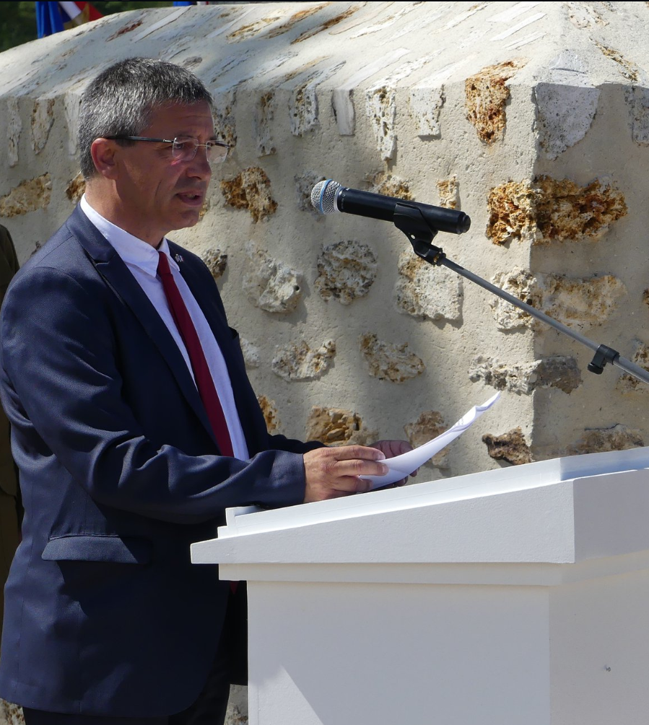 | Discours Nicolas Fricoteaux  Président départemental du conseil départemental de l’Aisne  Mémorial de la Ferme de la Croix Rouge – 28 juillet 2018

Monsieur le Préfet, Mesdames, Messieurs les Parlementaires, Mesdames, Messieurs les représentants des Ambassades, Monsieur le Maire, Mesdames et Messieurs les élus, Mesdames, Messieurs les membres de la Commission américaine du Centenaire, Mesdames, Messieurs les officiers, sous-officiers et soldats des armées américaine et française, Mesdames, Messieurs les porte-drapeaux et membres d’associations patriotiques, Chers amis,
Since almost four years, the centennial of the First World War has given rise to the organization of international commemorations bringing together the countries and peoples who, a century ago, fought on the soil of the department of Aisne, one of the most shaken by the Great War.
Today, we commemorate the intervention of the American troops in the battles who led to the liberation of our region and to the Allied victory of 1918.
In July 1918, almost a year ago, Americans and French were united in a battle of a rare violence.
In this place, on 26 and 27 July 1918, the soldiers of the 42nd American Division gained control, at the cost of appalling losses, of the Red Cross farm, held by formidable German defenders. The assault by 2 battalions of the 167th Alabama Infantry Regiment, supported by the 168th Infantry Regiment, and the artillery of the 26th American Division, the "Yankee Division", were to result in the loss of hundreds of men on both sides. As the German resistance collapsed, the entire 42nd Division continued to pursue the retreating enemy accross the Ourcq, allowing French troops to enter Fère-en-Tardenois.
Many American soldiers who lost their lives in these battles lie in the American cemetery at Seringes-et-Nesles. In 2011, the sumptuous American Memorial of the Red Cross Farm came to recall these deeds.
This memorial brings together our two nations around a shared memory that it is our duty to maintain and transmit.
It demonstrates the strength of Franco-American friendship and the commitment on both sides to commemorate the history of this alliance.
In the Aisne, the memory of the American intervention during the Great War never faded.
First, because the towns and villages, represented here today by their elected representatives, have for a century maintained this memory and the gratitude towards the Sammies, as the French population called them then. This is of course the case in Château-Thierry, Belleau, Fère-en-Tardenois or Seringes-et-Nesles, but also in many other communes of the Department.
It is also because humanitarian and economic reconstruction aid from the United States of America has been particularly important in Aisne. And I am thinking in particular here of the action of CARD and Anne Morgan, at the Château de Blérancourt, which has become a national museum, and has since a long time kept alive the memory of this philanthropic and humanist aid, so precious to our department.
The centennial of the American intervention is today celebrated in all the communities that welcomed these soldiers of hope: on the former front line, in the cantonment sites and, of course, in the places where lie to rest those who did not have the chance to see their country aain.
In the Aisne, the involvement of all the inhabitants is measured by the number of initiatives and projects approved by the World War One Centennial Commission and the French Centenary Mission, as well as by the Aisne County Council.
In this context, I would therefore like to welcome today the mobilization of the Tardenois territory on behalf of these commemorations.
This tribute embodies the spirit of harmony that unites nations around a shared memory that we strive, every day, to maintain and transmit to the greatest number.
Around the memory of the Great War, the United States and France are working together to preserve the ties that unite them and to build bridges between our two countries.
Because this centennial must also reach out, more broadly, to the citizens of all the countries that share this common history and it is our responsibility to ensure that they are welcomed on our territory. The Aisne, which was, between 1914 and 1918, the theatre of world history, must today rise to the challenge of memory which is its own.
The Department must promote memory tourism and be able to welcome, in the best conditions, those who are thirsty to know, to understand, to honor and, sometimes are undertaking the journey from as far away as the United States in the footsteps of a disappeared ancestor, to discover their own history.
Our thanks therefore go to the American representatives here present, as well as to all the military and civilian institutions that made this day an event that will, I am sure, mark the history of the centennial in the Aisne and the Franco-American friendship.
To welcome our American friends today, those who have always been our allies at the most tragic hours in our history, is a privilege and a just return for the debt we incurred towards them twice in the 20th century.
Let me end by quoting General Douglas Mac Arthur, who commanded the 42nd American Division in France in 1918:
"We do not become old for having lived a certain number of years, we become old because we have deserted our ideal. The years wrinkle the skin; to renounce one’s ideal wrinkle the soul. »
By coming together, a hundred years later, in these places that have suffered so much, we show that we have never renounced our ideal, the ideal that unites Americans and French today, the ideal of love for freedom and democracy.
Long live France,
Long live the United States of America,
And long live Franco-American friendship.

