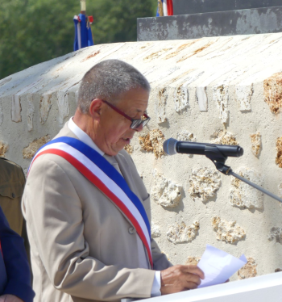 | Discours Jean-Paul Roseleux  Maire de Fère-en-Tardenois  Mémorial de la Ferme de la Croix Rouge – 28 juillet 2018

I cannot begin speaking today without expressing my gratitude.

Thank you to all who have worked so hard to make this moment of memory be also a moment of sharing and conviviality

I will leave it to others to tell you the history of this place.

I would simply like to tell you the story of this Pietà and the beautiful encounters she has allowed.
The story begins with the one who has become a friend Monique Brouillet - Seefried.

Those lucky enough to know her know that her commitment is always full and complete. When she is convinced to fight for the good cause no obstacle stops her.

For the record, we can identify this dead soldier. His identification plate tells us that he is Sergeant Worth Lewis of the 167th Infantry Regiment, 42nd Division, a soldier of Alabama, who died on July 26, 1918, on this soil, and is buried in the cemetery of Seringes and Nesle.

Then comes the one who is at the origin and who carried the project: Nimrod Frazer.

This monument was erected in memory of his father, Sergeant Frazer, wounded here on July 26, 1918 and also in memory of his comrades, dead and wounded, on French battlefields.

The same bronze Rainbow soldier stands today in front of the Montgomery Alabama Station, from where the Alabama National Guard soldiers departed in 1917 to join the 42nd US Division.

The town where Camille Claudel was born is particularly proud to be the custodian of such a masterpiece and wishes that this sculpture be dedicated to the memory of all these men, of whatever nationality, who have left their lives during these fratricidal conflicts.

